**LEARNING MANAGEMENT SYSTEM**

**A Project Report Submitted**

**in Partial Fulfilment of the Requirements for the Degree**

**of**

**BACHELOR OF TECHNOLOGY**

**in**

**INFORMATION TECHNOLOGY**

**By**

**Alok Kr. Maity (10700217048)**

**Surjyakanta Das (10700217004)**

**UNDER THE GUIDANCE**

**OF**

**Prof. Rinku Khatua**



**DEPARTMENT OF INFORMATION TECHNOLOGY COLLEGE OF ENGINEERING AND MANAGEMENT, KOLAGHAT (Affiliated to Maulana Abul Kalam Azad University of Technology, West Bengal) KTPP TOWNSHIP; KOLAGHAT**

**PURBO MEDINIPUR, WEST BENGAL; PIN-721171**

**Nov-2020-21**

**ACKNOWLEDGEMENTS**

It gives us great pleasure to find an opportunity to express our deep and sincere gratitude to our project guide **Prof. Rinktu Khatua**. We do very respectfully recollect **her** constant encouragement, kind attention and keen throughout the course of our work. We are highly indebted to **her** for the way **she** modeled and structured our work with **her** valuable tips and suggestions that **she** accorded to us in every aspect of our work.

We are extremely grateful to our department Information Technology, CEMK, extending all the facilities of our department.

We humbly extend our sense of gratitude to other faculty members, laboratory staff, library staff and administration of the institute for providing us their valuable help and time with a congenital working environment.

Last but not the least, we would like to convey our heartiest thanks to all our classmates who time to time have helped us with their valuable suggestion during our project work.

*Alok Kr. Maity*

__________________________

Date: 09.03.21 Alok Kr. Maity (10700217048)

*Surjyakanta Das*

__________________________

Surjyakanta Das(10700217004)

**DEPARTMENT OF INFORMATION TECHNOLOGY**

**COLLEGE OF ENGINEERING AND MANAGEMENT, KOLAGHAT (Affiliated to Maulana Abul Kalam Azad University of Technology, West Bengal) KTPP TOWNSHIP; KOLAGHAT**

**PURBO MEDINIPUR, WEST BENGAL; PIN-721171**



**CERTIFICATE OF APPROVAL**

This is to certify that the project titled “Learning Management System” is the bona fide work carried out by

*Alok Kr. Maity (10700217048) and*

*Surjyakanta Das (10700217004),*

students of B. Tech (IT) of College of Engineering and Management, Kolaghat affiliated to Maulana Abul Kalam Azad University of Technology, West Bengal, during the academic year **2020-21**, in partial fulfilment of the requirements for the award of the degree of Bachelor of Technology in Information Technology and that the project has not formed the basis for the award previously of any other degree, diploma, fellowship or any other similar title.

**____________________**

**Name, Designation and**

**Signature of the Guide**

**Counter Signed By**

**__________________**

**Dr. Jaydev Mishra**

**HOD, IT**

**Place:**

**Date:**

**DEPARTMENT OF INFORMATION TECHNOLOGY**

**COLLEGE OF ENGINEERING AND MANAGEMENT, KOLAGHAT (Affiliated to Maulana Abul Kalam Azad University of Technology, West Bengal) KTPP TOWNSHIP; KOLAGHAT**

**PURBO MEDINIPUR, WEST BENGAL; PIN-721171**



**CERTIFICATE BY BOARD OF EXAMINERS**

This is to certify that the project work entitled “Learning Management Systems” submitted by Alok *Kr. Maity (10700217048) and*

*Surjyakanta Das (10700217004),*

to the department of Information Technology of College of Engineering and Management, Kolaghat has been examined and evaluated.

This project work has been prepared as per the regulations of the Maulana Abul Kalam Azad University of Technology, West Bengal and qualifies to be accepted in partial fulfilment of the requirement for the degree of B. Tech in Information Technology.

_______________ Board of Examiner

Signature of

Project Coordinator ________________

___________________

**List of Figures**

FIGURE 1 MERN STACK................................................................................................................

FIGURE 2 MongoDB........................................................................................................................

FIGURE 3 Express JS........................................................................................................................

FIGURE 4 React JS...........................................................................................................................

FIGURE 5 Node JS............................................................................................................................

FIGURE 6 User Case Model.............................................................................................................

FIGURE 7 Data Flow Diagram.........................................................................................................

FIGURE 8 E-R Diagram....................................................................................................................

**Abstract**

In the recent years, there has been increasing technologies into educational processes. Learning Management System (LMS) as a web-based technology in educational program provides support to instructor to reach their pedagogical goal, organize course contents and support students. The purpose of LMS is to automate the existing manual system by the help of computerized equipment’s and full-fledged computer software, fulfilling their requirements, so that their valuable data/information can be stored for a longer period with easy accessing and manipulation of the same. The required software and hardware are easily available and easy to work with. LMS, as described above, can lead to error free, secure, reliable and fast management system. It can assist the user to concentrate on their other activities rather to concentrate on the record keeping. Thus, it will help organization in better utilization of resources. The organization can maintain computerized records without redundant entries. That means that one need not be distracted by information that is not relevant, while being able to reach the information. For this project we are using web-based technology called MERN which is a collection of different web-technologies that we will discuss here.

**Functionalities provided by LMS:**

* Provide the searching facilities based on various factors. Such as Assignment, Teacher, Quiz, Question etc.
* It tracks all the information of student, Class and Quiz etc.
* Manage the information of student.
* Show the information and description of the Assignment.
* Show the information and description of the Assignment, Teacher.
* To increase efficiency of managing the Assignment, Student.
* It deals with monitoring he information and transaction of Quiz.
* Manage the information of Assignment.
* Manage the information of Quiz.
* Integration of all records of Question.

**CONTENTS Page No.**

**Acknowledgement……………………………………………………………….2**

**Certificate of Approval………………………………………………………….3**

**Certificate by Board of Examiner………………………………………………4**

**List of Figures……………………………………………………………………5**

**Abstract…………………………………………………………………………...6**

**Chapter 1: Introduction………………………………………………………….8**

1. Introduction
   1. Problem Statement………………………………………………………………….8
   2. Innovative Ideas of Project…………………………………………………………9
   3. Project Objective……………………………………………………………………9
   4. Scope of The Project……………………………………………………..................9
   5. What is MongoDB?...................................................................................................9
      1. Key Components of MongoDB Architecture ………………………….10
   6. What is Express.js?...................................................................................................10
      1. Why use express?.....................................................................................11
   7. What is React?...........................................................................................................11
      1. Why use React?........................................................................................12
   8. What is Node.js?........................................................................................................12

1.8.1 Features of Node.js …………………………………………………13

**Chapter 2: Literature Study and Scope of work………………………………14**

* 1. System Requirement…………………………………………………….14
     1. Hardware Requirement…………………………………………………………14
     2. Software Requirement…………………………….………………...…………14
  2. System Design………………………………………………………….14
     1. Admin Module…………………………………………………………………14
     2. Techer Module…………………………………………………………………14
     3. Student Module…………………………………………………………….….15
  3. System Diagrams……………………………………………………….15
     1. User Case Diagram…………………………………………………………….15
     2. Data Flow Diagram…………………………………………………………….16
     3. E-R diagram…………………………………………………………………….17

**Chapter 3: References………………………………………………………….19**

**Chapter 1: INTRODUCTION**

**1.0 Introduction**

Today Developers around the world are making efforts to enhance user experience of using application as well as to enhance the developer’s workflow of designing applications to deliver projects and rollout change requests under strict timeline. Stacks can be used to build web applications in the shortest span of time. The stacks used in web development are basically the response of software engineers to current demands. They have essentially adopted pre-existing frameworks (including JavaScript) to make their lives easier.

While there are many, MEAN and MERN are just two of the popular stacks that have evolved out of JavaScript. Both stacks are made up of open-source components and offer an end-to-end framework for building comprehensive web apps that enable browsers to connect with databases. The common theme between the two is JavaScript and this is also the key benefit of using either stack. One can basically avoid any syntax errors or any confusion by just coding in one programming language, JavaScript. Another advantage of building web projects with MERN is the fact that one can benefit from its enhanced flexibility.

In order to understand MERN stack, we need to understand the four components that make up the MERN stack(fig.1), namely – MongoDB, Express.js, React and Node.js.

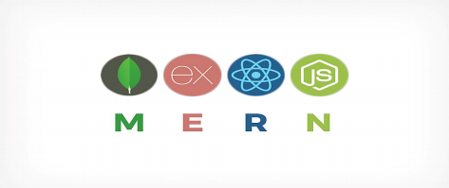

Figure MERN STACK

**1.1 Problem Statement**

* The project is to create an online learning management system with a server and users to enable the online study.
* To make the online study easier and more efficient using.
* The project should be very easy to use enabling any one can use it.

**1.2 Innovative Ideas of Project**

* **GUI:** Easy to use GUI (Graphical User Interface), hence any user with minimal knowledge of operating a system can use the software.
* **Platform Independence:** As it is a web-based project so it is not dependent on any platform or we can say it is platform independent.

**1.3 Project Objective**

* **Simplify Online Study:** The main objective of this project is to simplify online study.

**1.4 Scope of The Project**

* Learning Management System (LMS)is a web-based online learning system that enables teachers and student to communicate with each other easily and make the process of online learning easy. It may help collecting perfect management in details. In a very short time, the collection will be obvious, simple and sensible. It will be helping a person to know the management of passed year perfectly and vividly.
* Institutes like to have a software wherein they can continue there education online.

**1.5 What is MongoDB?**



Figure MongoDB

* MongoDB is a cross-platform document-oriented NoSQL database used for high volume data storage that provides high performance, high availability and easy scalability.
* MongoDB stores data in flexible, JSON-like documents, meaning fields can vary from document to document and data structure can be changed over time. The document model maps to the objects in the application code, making data easy to work with.
* The data model available within MongoDB allows users to represent hierarchical relationships, to store arrays, and other more complex structures more easily.
* MongoDB works on concept of collections and documents. Each database contains collections which in turn contains documents. Each document can have varying number of fields. The size and content of each document can also be different from each other.

**1.5.1 Key Component of MongoDB Architecture**

**1. _id -** This is a 24-digit unique identifier field required in every MongoDB document in the collection. The _id field is like the document's primary key. If the user creates a new document without an _id field, MongoDB will automatically create the field.

**2. Collection -** Collection is a group of MongoDB documents. It is the equivalent of an RDBMS table. A collection exists within a single database. Collections do not enforce a schema. Typically, all documents in a collection are of similar or related purpose.

**3. Document** - A document is a set of key-value pairs. Documents have dynamic schema. Dynamic schema means that documents in the same collection do not need to have the same set of fields or structure, and common fields in a collection's documents may hold different types of data.

**4. Database -** Database is a physical container for collections. Each database gets its own set of files on the file system. A single MongoDB server typically has multiple databases.

**5. Field -** A name-value pair in a document. A document has zero or more fields. Fields are analogous to columns in relational databases.

**1.6 What is Express.js?**



Figure Express JS

* Express is a minimal and flexible Node.js web application framework that provides a robust set of features for web and mobile applications. It is an open-source framework developed and maintained by the Node.js foundation.
* Express provides us the tools that are required to build our app, be it single-page, multi-page or hybrid web applications. It is flexible as there are numerous modules available on **npm (Node Package Manager)**, which can be directly plugged into Express.
* Unlike its competitors like Rails and Django, which have an opinionated way of building applications, Express has no "best way" to do something. It is very flexible and pluggable. • Pug (earlier known as Jade) is a terse language for writing HTML templates. It produces HTML, supports dynamic code and code reusability (DRY). It is one of the most popular template languages used with Express.
* Express can be thought of as a layer built on the top of the Node.js that helps manage a server and routes. It allows users to setup middleware to respond to HTTP Requests and defines a routing table which is used to perform different actions based on HTTP method and URL.
* Express allows to dynamically render HTML Pages based on passing arguments to templates.
* Express is asynchronous and single threaded and performs I/O operations quickly.

**1.6.1 Why use Express?**

* Ultra-fast I/O.
* Asynchronous and single threaded.
* MVC like structure.
* Robust API makes routing easy.

**1.7 What is React?**



Figure React JS

* ReactJS is a declarative, efficient, and flexible JavaScript library for building reusable UI components. It is an open-source, component-based front-end library which is responsible only for the view layer of the application. It was initially developed and maintained by Facebook and later used in its products like WhatsApp & Instagram.
* A ReactJS application is made up of multiple components, each component responsible for outputting a small, reusable piece of HTML code. The components are the heart of all React applications. These Components can be nested with other components to allow complex applications to be built of simple building blocks. ReactJS uses virtual DOM based mechanism to fill data in HTML DOM. The virtual DOM works fast as it only changes individual DOM elements instead of reloading complete DOM every time.
* Instead of using regular JavaScript, react codes are written in something called JSX (JavaScript Syntax Extension). JSX is basically a syntax extension of regular JavaScript and is used to create React elements. These elements are then rendered to the React DOM. JSX is faster than normal JavaScript as it performs optimizations while translating to regular JavaScript.

**1.7.1 Why use React?**

* Uses virtual DOM which is a JavaScript object. This will improve apps performance, since JavaScript virtual DOM is faster than the regular DOM.
* Can be used on client and server side as well as with other frameworks.
* Component and data patterns improve readability, which helps to maintain larger apps.

**1.8 What is Node.js?**

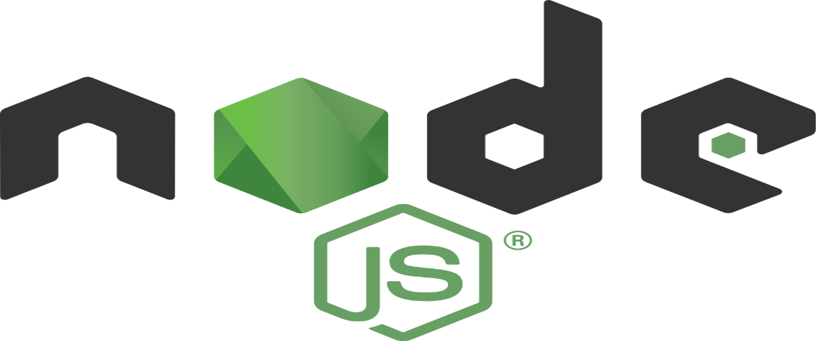

Figure Node JS

* Node.js is a very powerful JavaScript-based platform built on Google Chrome's JavaScript V8 Engine. It is used to develop I/O intensive web applications like video streaming sites, single page applications, and other web applications. Node.js is open source, completely free, and used by thousands of developers around the world.
* Node.js is a server-side platform built on Google Chrome's JavaScript Engine (V8 Engine). Node.js was developed by Ryan Dahl in 2009.
* Node.js applications are written in JavaScript and can be run within the Node.js runtime on OS X, Microsoft Windows, and Linux.
* Node.js also provides a rich library of various JavaScript modules which simplifies the development of web applications using Node.js to a great extent.
  + 1. **Features of Node.js?**

1. **Extremely fast:** Node.js is built on Google Chrome's V8 JavaScript Engine, so its library is very fast in code execution.
2. **I/O is Asynchronous and Event Driven:** All APIs of Node.js library is asynchronous i.e. non-blocking. So, a Node.js based server never waits for an API to return data. The server moves to the next API after calling it and a notification mechanism of Events of Node.js helps the server to get a response from the previous API call. It is also a reason that it is very fast.
3. **Single threaded:** Node.js follows a single threaded model with event looping.
4. **Highly Scalable:** Node.js is highly scalable because event mechanism helps the server to respond in a non-blocking way.
5. **No buffering:** Node.js cuts down the overall processing time while uploading audio and video files. Node.js applications never buffer any data. These applications simply output the data in chunks.
6. **Open Source:** Node.js has an open-source community which has produced many excellent modules to add additional capabilities to Node.js application.

**Chapter 2: LITERATURE STUDY AND SCOPE OF WORK**

This project is mainly focused to provide a user-friendly environment to the students as well as teacher and give everyone a chance to learn, irrespective of where they are. So, in this project we are implementing MERN stack technology as explained above. So, now let’s see the system requirements for this project development –

**2.0 SYSTEM REQUIREMENT:**

**2.0.1 HARDWARE REQUIREMENT: -**

* Processor: Intel i3 processor or Greater
* RAM: 4GB or Greater
* HARDDISK: 2 Giga Byte (GB) or greater
* Keyboard & Mouse
* Monitor or Laptop: 1280*800 minimum screen resolution

**2.0.2 SOFTWARE REQUIREMENT: -**

* Operating System: windows 7/8/10 or Linux or Mac
* Pre-installed: Node.js, React.js and MongoDB
* Tools: VS Code, MongoDBCompass

A **system diagram** is a visual model of a **system**, its components, and their interactions. With supporting documentation, it can capture all the essential information of a **system's** design. There are many variations of diagramming style that all fall under this rubric. There are different types of system diagrams

**2.2.1 User Case Diagram:**

use case model for any system consists of "use cases". Use cases represent different ways in which the system can be used by the user. A simple way to find all the use case of a system is to ask the questions "What the user can do using the system?" The use cases partition the system behaviour into transactions such that each transaction performs some useful action from the users' point of view.

**2.1 SYSTEM DESIGN:**

Now, let’s look at some of the system modules –

**2.1.1 Admin Module:**

So, there is an admin panel where admin can login and control everything of the site. The operations that admin can perform –

* Add and update a department.
* Add and delete notices in the site.
* Add, update and remove subjects for different departments.
* Add, update and delete student as well as teacher data
* View student and teacher activity on the site
* Can Assign head of the departments.

**2.1.2 Teacher Module:**

As it is a learning platform it requires teachers. So, there is a teacher panel where teacher can perform some operations. Now, we divided the teacher plane in two sections that are - Hod panel and teacher panel. Now some functionalities of HOD panel are –

* Assign, edit and delete class to another teacher and himself/herself.
* Take attendance of students of his/her class.
* View previous attendance of his/her class.
* View overall attendance report of all the students of department semester wise and also can export the data in excel or pdf format.
* Give assignments and view the responses from students.
* Provide study materials to the class for students.
* Take test (using google forms)
* Take a live class (using google meet)

Now, come to normal teacher the functionalities are –

* Take attendance of his/her class.
* View previous attendance date wise.
* Assign assignments to students and view responses.
* Provide study materials to the class for students.

**2.1.3 Student Module:**

In the student module the student has to login to access operations like –

* View attendance.
* Download the assignments.
* Upload the assignments.
* View and download study materials provided by the teacher of class.

**2.2 SYSTEM DIAGRAMS:**

* The purpose of the use case to define a piece of coherent behaviour Without revealing the internal structure of the system. A use case typically represents a sequence of interaction between the user and the system. These interactions consist of one main line sequence is represent the normal interaction between the user and the system. The use case model is an important analysis and design artifact (task). Use cases can be represented by drawing a use case diagram and writing an accompany text elaborating the drawing.
* In the use case diagram, each use case is represented by an ellipse with the name of use case written inside the ellipse. All the ellipses of the system are enclosed with in a rectangle which represents the system boundary. The name of the system being module appears inside the rectangle. The different users of the system are represented by using stick person icon. The stick person icon is normally referred to as an Actor. The line connecting the actor and the use cases is called the communication relationship. When a stick person icon represents an external system, it is annotated by the stereo system.

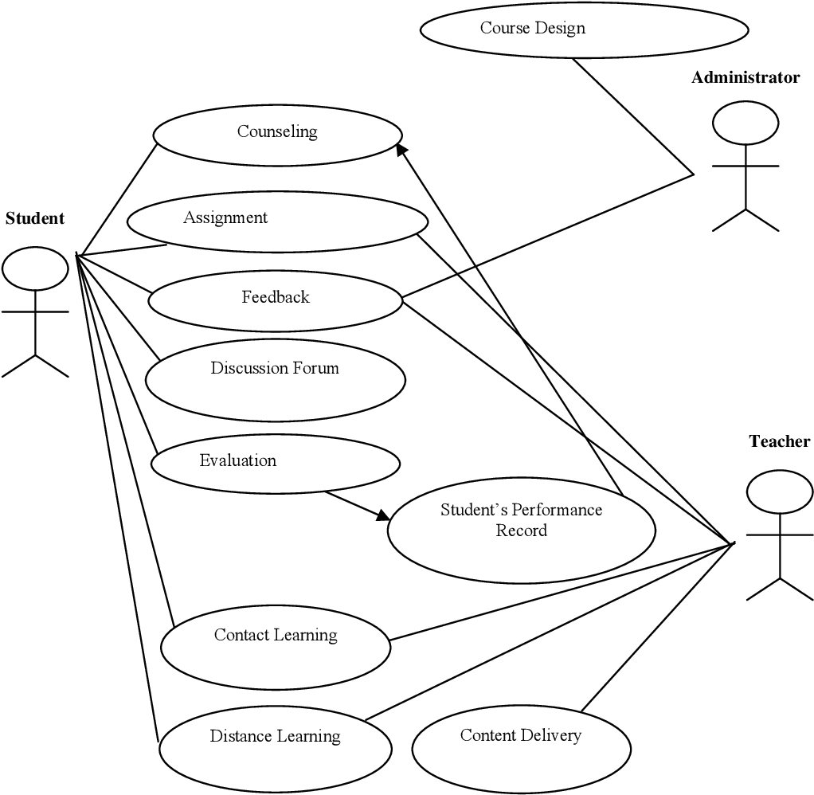

Figure User Case Model

**2.2.1 Data Flow Diagram:**

* Data flow diagram is the starting point of the design phase that functionally decomposes the requirements specification. A DFD consists of a series of bubbles joined by lines. The bubbles represent data transformation and the lines represent data flows in the system. A DFD describes what data flow rather than how they are processed, so it does not hardware, software and data structure.
* **A data-flow diagram (DFD)** is a graphical representation of the "flow" of data through an DFDs can also be used for the of processing (structured design). A data flow diagram (DFD) is a significant modelling technique for analysing and construct ng information processes. DFD literally means an illustration that explains the course or movement of information in a process. DFD illustrates this flow of Information in a process based on the inputs and outputs. A DFD can be referred to as a Process Model. The data flow diagram is a graphical description of a system's data and how to Process transform the data is known as Data Flow Diagram (DFD). Unlike details flow chart, DFDs don't supply detail descriptions of modules that graphically describe a system's data and how the data interact with the system. Data flow diagram number of symbols and the following symbols are of by DeMarco.

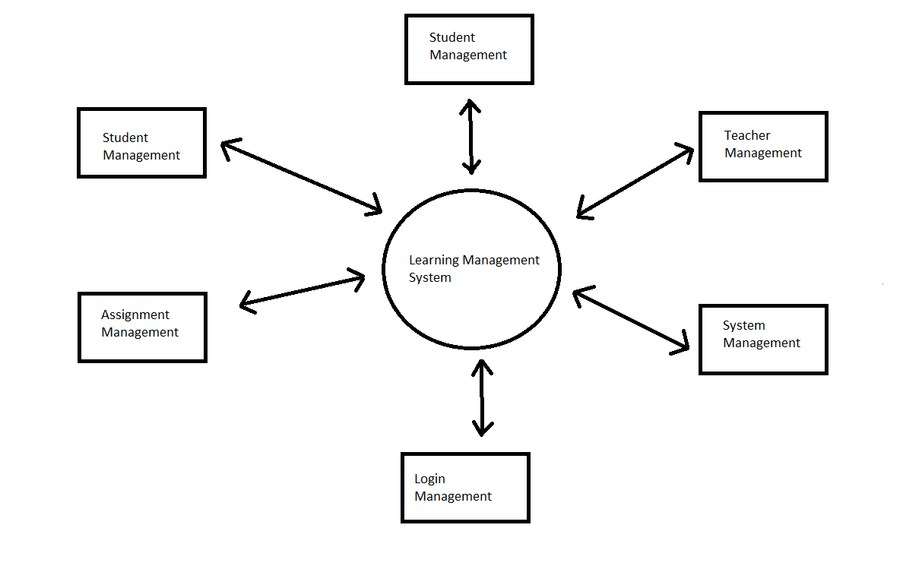

Figure Data Flow Diagram

**2.2.1 E-R Diagram:**

* E-R Model is a popular high level conceptual data model. This model and its variations are frequently used for the conceptual design of database application and many database design tools employ its concept.
* A database that to an E-R diagram can be represented by a collection of tables in the relational system. The mapping of E-R diagram to the entities are:
* Attributes
* Weak Entities
* Relations
  + Many-to-many
  + Many-to-one
  + One-to-many
  + One-to-one
* Sub-type and super-type

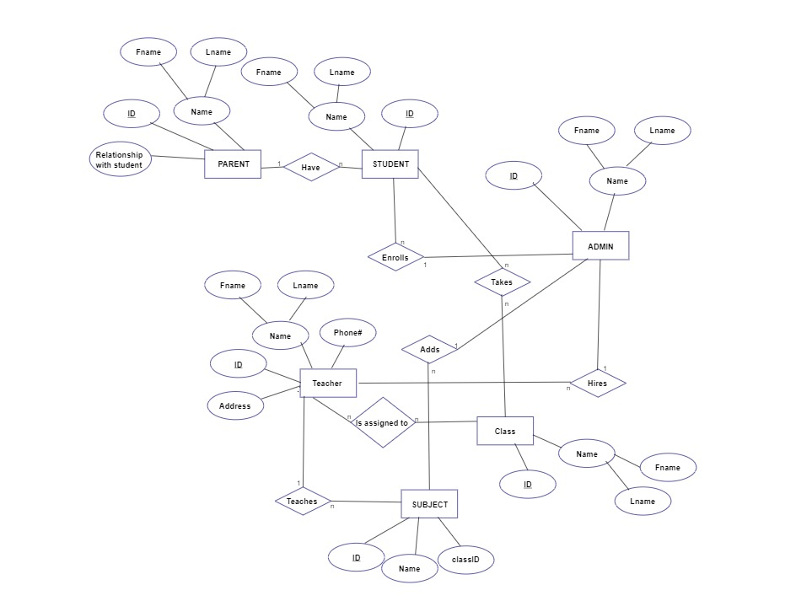

Figure E-R diagram

**Chapter 3: REFERENCES**

1. MongoDB: <https://docs.mongodb.com/ecosystem/drivers/>
2. ExpressJS: <https://expressjs.com/en/guide/routing.html>
3. Npm: <https://www.npmjs.com/>
4. ReactJS: <https://reactjs.org/docs/getting-started.html>
5. NodeJS: <https://nodejs.org/en/docs/>